AWS Lambda
let's build an automated EBS backup Lambda that finds all EC2 instances tagged Backup=true and creates snapshots of their attached volumes

What we're building
Lambda scans EC2 instances → filters by tag Backup = true → creates EBS snapshots for each attached volume → tags the snapshots for tracking. Triggered on a schedule (EventBridge) but testable manually in the Console.

Step 1: Tag an EC2 instance for backup
- Go to EC2 Console → select an existing instance (or launch a small t2.micro for testing)
- Ec2 Name: ec2_for_lambda_X
- Tags tab → Manage tags → Add tag
  - Key: Backup
  - Value: true
- Save
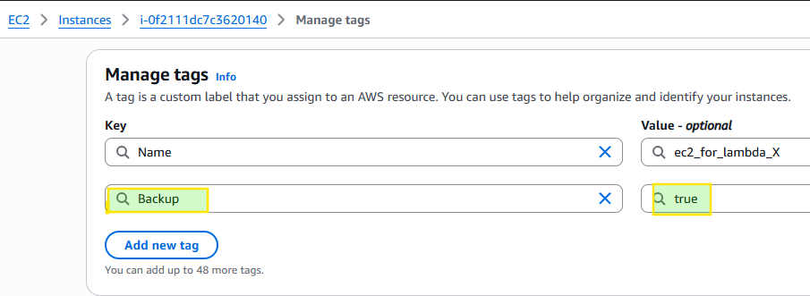
Step 2: Create the Lambda function
- Lambda Console → Create function → Author from scratch
- Name: ec2-tagged-backup_X
- Runtime: Python 3.13
- Create a new execution role with basic Lambda permissions
- Click Create function
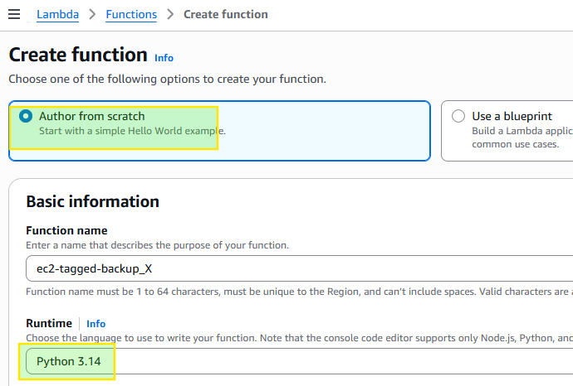
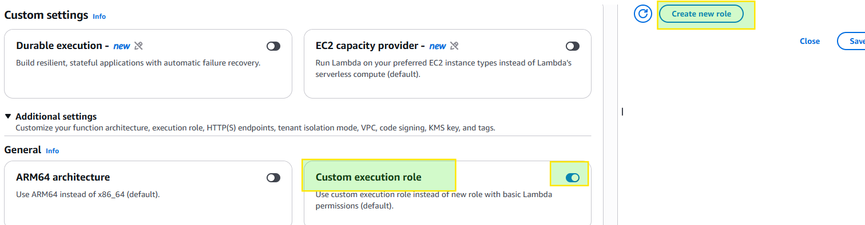
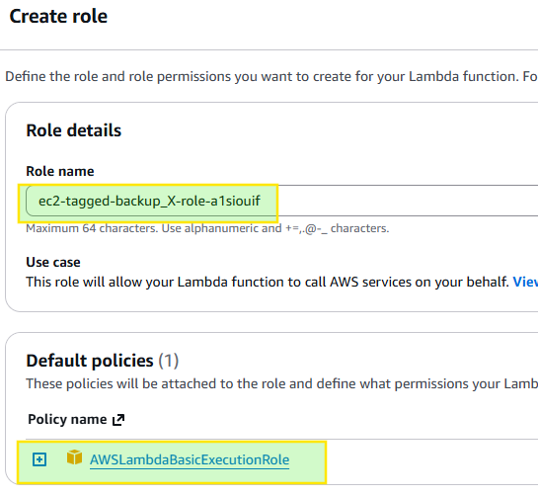

Step 3: Function code

import boto3
from datetime import datetime

ec2 = boto3.client('ec2')

def lambda_handler(event, context):
# Find instances tagged Backup=true
response = ec2.describe_instances(
Filters=[
{'Name': 'tag:Backup', 'Values': ['true']},
{'Name': 'instance-state-name', 'Values': ['running', 'stopped']}
]
)

instances_backed_up = []
volumes_snapshotted = []

for reservation in response['Reservations']:
for instance in reservation['Instances']:
instance_id = instance['InstanceId']
instances_backed_up.append(instance_id)
print(f"Found tagged instance: {instance_id}")

# Snapshot every EBS volume attached to this instance
for mapping in instance.get('BlockDeviceMappings', []):
volume_id = mapping['Ebs']['VolumeId']
device_name = mapping['DeviceName']

snapshot = ec2.create_snapshot(
VolumeId=volume_id,
Description=f"Automated backup of {volume_id} ({device_name}) on {instance_id}",
TagSpecifications=[
{
'ResourceType': 'snapshot',
'Tags': [
{'Key': 'Name', 'Value': f"backup-{instance_id}-{device_name}"},
{'Key': 'SourceInstance', 'Value': instance_id},
{'Key': 'CreatedBy', 'Value': 'lambda-auto-backup'},
{'Key': 'Date', 'Value': datetime.utcnow().strftime('%Y-%m-%d')}
]
}
]
)
snapshot_id = snapshot['SnapshotId']
volumes_snapshotted.append(snapshot_id)
print(f"Created snapshot {snapshot_id} for volume {volume_id}")

return {
'statusCode': 200,
'instances_processed': instances_backed_up,
'snapshots_created': volumes_snapshotted
}
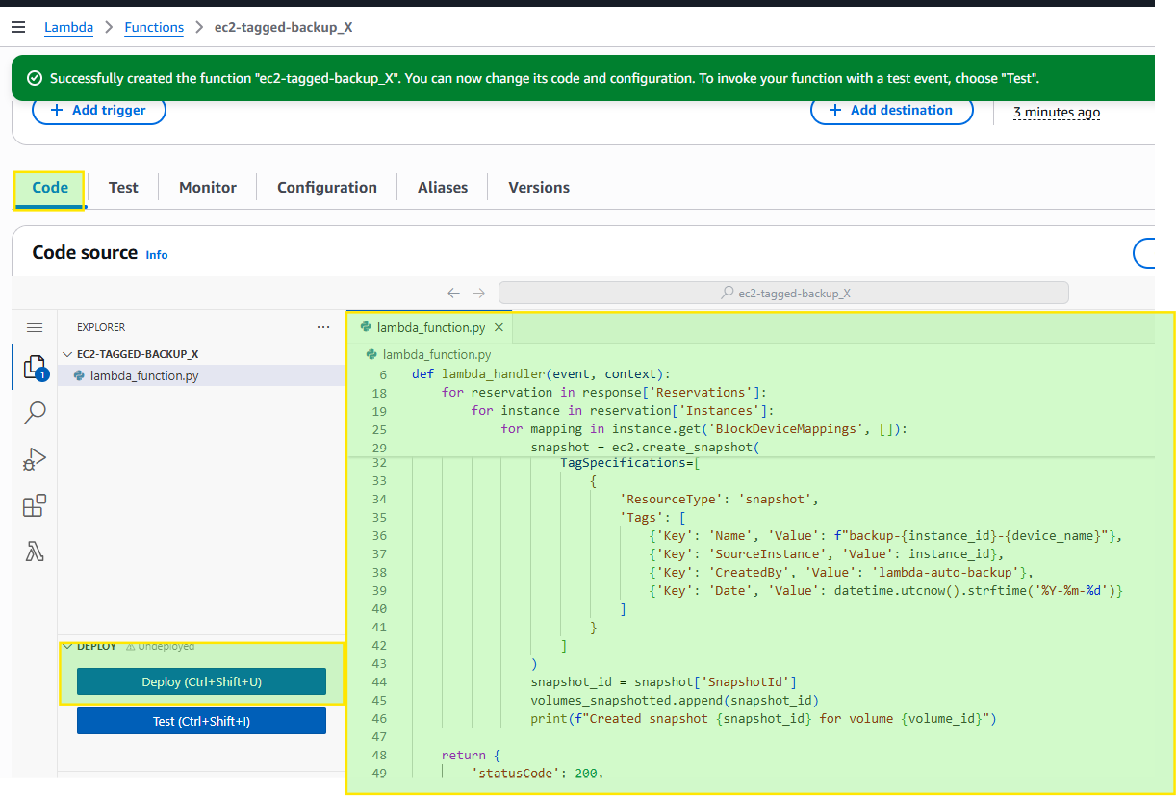

Step 4: Fix the IAM permissions
The default role only has basic logging permissions. Add EC2 rights:
- Configuration → Permissions → click the role name (opens IAM)
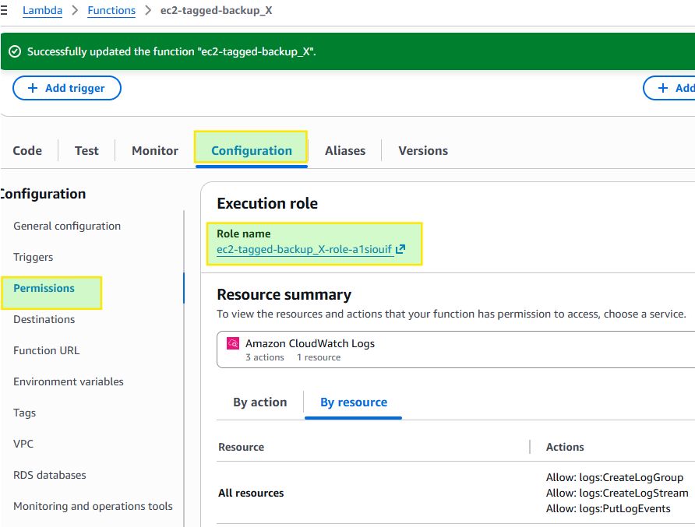
2. Add permissions → Create inline policy
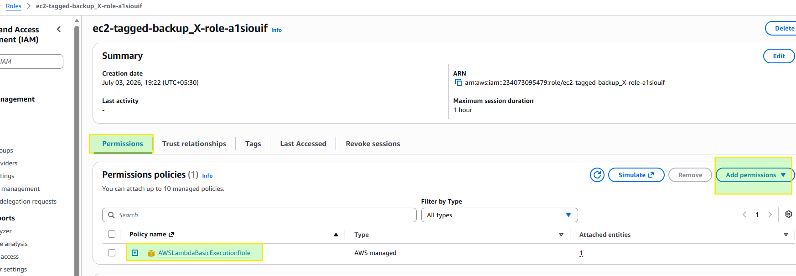
3. Switch to JSON tab, paste:
{
"Version": "2012-10-17",
"Statement": [
{
"Effect": "Allow",
"Action": [
"ec2:DescribeInstances",
"ec2:DescribeVolumes",
"ec2:CreateSnapshot",
"ec2:CreateTags"
],
"Resource": "*"
}
]
}

- Name it EC2BackupPolicy_X → Create policy
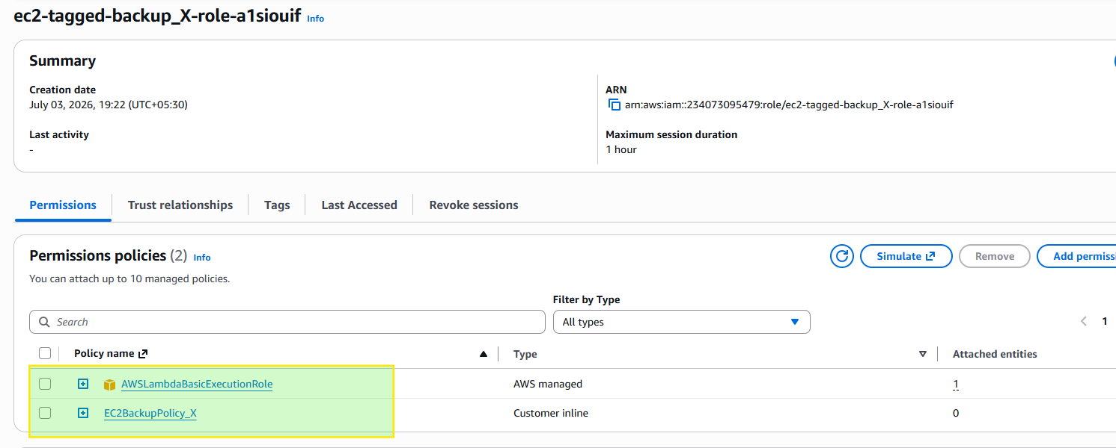
Step 5: Increase the timeout (optional but recommended)
Snapshot creation is fast to initiate, but if you have many instances, bump the timeout:
- Configuration → General configuration → Edit → Timeout: 30 sec → Save

Step 6: Test it in the Console
- Go to the Test tab
- Create a new test event — since this function doesn't rely on the incoming event data at all (it queries EC2 directly), you can just use the default {} empty JSON, or the hello-world template as-is
Invocation type: Synchronous
Event sharing settings: Private
- Name it ManualBackupTrigger, save, click Test
Check the Execution results:
{
"statusCode": 200,
"instances_processed": ["i-0abcd1234efgh5678"],
"snapshots_created": ["snap-0123456789abcdef0"]
}

- Go to EC2 Console → Snapshots (left sidebar under Elastic Block Store) to confirm the snapshot actually appeared.
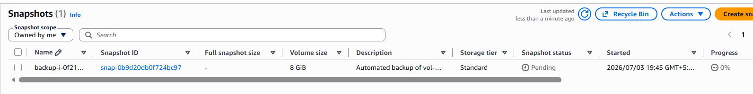

Step 7 (optional): Automate it on a schedule
To make this a real backup system instead of a manual test:
- Configuration → Triggers → Add trigger
- Select EventBridge (CloudWatch Events)
- Create new rule → Schedule expression: rate(1 day) (or cron(0 3 * * ? *) for 3 AM daily)
- Save
Now it runs automatically every day against any instance tagged Backup=true.

